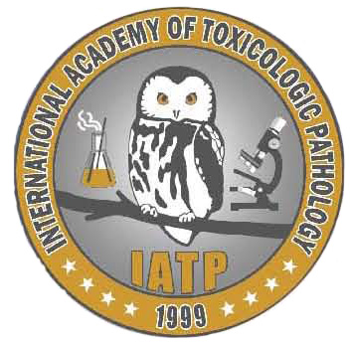
IATP Charles Capen Trainee Award Book Voucher

Please complete your book mailing label below.
Please note, we cannot mail to PO Box addresses:

Name:
Address line 1:
Address line 2:
City:
State:
Country:
Zip/Postal Code:
Phone No.
E-mail:

Please select one book from the list provided below by placing an “x” in the order column:

Title | Authors | Order
Fundamental Neuropathology for Pathologists and Toxicologists: Principles and Techniques | Bolon B and Butt M
Histopathology of Preclinical Toxicity Studies, 4th ed. | Greaves P
Fundamentals of Toxicologic Pathology, 2nd ed. | Haschek W and Rousseaux C
Haschek and Rousseaux's Handbook of Toxicologic Pathology, 3rd ed. | Haschek et al
Background Lesions in Laboratory Animals | McInnes
Toxicologic Pathology: Nonclinical Safety Assessment | Sahota et al
Boorman's Pathology of the Rat, 2nd ed. | Suttie A and Leininger J
Comparative Anatomy and Histology: A Mouse and Human Atlas | Treuting P and Dintzis S
Hayes’ Principles and Methods of Toxicology, 6th ed. | Hayes W and Kruger C

Return your completed voucher to: IATP Executive Office By mail: 116 White Owl Trail, Mullica Hill NJ 08062. By email: iatpfellows@verizon.net By fax: (856) 223-9444

Please direct any questions to Stephanie Dickinson, iatpfellows@verizon.net or (856)223-5174.

